Glowtag FD-04 — Power-Ups
Owns the item set, the crates, distribution, and the power-up UI.

The design rule
No power-up is aimed at a specific player. Everything is self-affecting or environmental, and all catch-up pressure lives in what the crate rolls, which the recipient experiences as luck and the leader never experiences as an attack.
This is why there is no targeted slow or EMP. An effect that takes agency from a chosen player is always attributed to the player who used it, and in a ninety-second round with six players everyone knows exactly who did it to them. Frustration here is not about the size of an effect — it is about whether it was aimed.
Two hard constraints. Nothing may stop, disable or steer another player's robot — the foundation's final clamp guarantees steering authority is never zero, and no Glowtag modifier may work against that. And nothing is named, modelled or presented as a weapon; everything is a tool, a system or an upgrade.
One honest revision. An earlier draft of this rule said "self-affecting only". With Oil Slick and Repulse Pulse in the set, that is no longer true and pretending otherwise would misdescribe the design. The surviving rule is the one that was always doing the work: not aimed, and never removes control. Both items pass it — oil is a surface anyone can see and drive around, and a repulse is a shove that affects everyone nearby equally behind a visible charge-up.

Crates
Power-ups come from a generic item crate. The player does not know what is inside until they break it; the roll is revealed on pickup.
Rule | Detail
Appearance | One crate model for every item. No per-item pad art, which is one asset instead of five for the 3D generalist
Reveal | On pickup, a brief roll-and-settle of about half a second in the slot, then the item is shown
Consequence for weighting | The roll is hidden by construction. The distribution bias below is invisible without any effort to hide it, because the player never had an expectation to violate
Respawn | Per-crate timer after collection
Arm delay | Inert for crate_arm_delay after spawning, so one cannot materialise under a moving robot
Authority | Not props. Props are cosmetic and non-authoritative in the foundation; crates are gameplay objects and resolve on the authority

The set
Five items.
Item | Effect | Role | Notes
Overdrive | Fires a boost immediately for overdrive_ticks, on demand. Separate from the drift-charged boost — no drift, no window, no press timing | Universal | Uses the foundation's boost, so it also carries boost_bump_multiplier — Overdrive is a steal tool, not just a chase tool. Precedent exists: boost pads "grant a fixed boost on contact, no window, no press"
Grapple Field | For grapple_ticks, your steal reach extends slightly past your chassis, so a near-miss still takes the Crown | Chaser only | Structurally self-balancing — does nothing if you already hold the Crown, so it only ever helps someone chasing. The best-behaved item in the set
Damper Field | For damper_ticks, contacts push you normally but cannot take the Crown | Holder only | Gives possession a defensible window, so a good holder is not simply swarmed. Must show a visible ring to opponents — a defensive effect a chaser cannot see reads as cheating, and they will waste three hits learning it
Oil Slick | Drops an Oil surface patch behind you | Environmental | Costs almost nothing: the Oil surface already exists in Handling Profiles, tuned and annotated "intended for a dropped power-up". Ice costs control, sand costs speed, and oil is deliberately the sharper, briefer version of ice
Repulse Pulse | Short-range omnidirectional shove with a visible charge-up | Environmental | Deliberately rare. Affects everyone nearby equally rather than being aimed, and telegraphs itself so opponents can react. Same fantasy as an EMP, none of the frustration

On Overdrive and the boost economy
Overdrive fires a boost directly rather than granting reserve to convert. That keeps it usable at a moment of the player's choosing, which is the whole point of holding one item.
Where it meets a drift-earned boost, the foundation's existing rule applies unchanged: two boosts on the same tick "resolve as one chain link taking the higher of the two multipliers, not two links and not additive." So Overdrive can extend a chain but cannot be stacked onto one for double value.
Provisional strength is stage 2 equivalent — solid, but never better than a well-executed chain, so skill still tops out above the pickup.

Phase-two pool
Not shipping. Listed so any can be promoted after playtests.
Item | Effect | Note
Traction Boost | Better grip and tighter turning briefly | Now trivially cheap — a transient modifier on lateral_grip and steer_response. The purest "help a weaker player" item, since cornering is what skill actually buys
Route Scan | Briefly highlights the intercept line to the holder | Information rather than mechanics. Helps weaker players by teaching them where to go, which suits a platform whose reason for existing is teaching
Data Surge | Doubles score rate while holding, briefly | Powerful and snowball-prone. Only viable once the distribution weighting is confirmed working

Distribution — where catch-up actually lives
With the endgame multiplier cut in FD-01, this is the mode's only catch-up system.
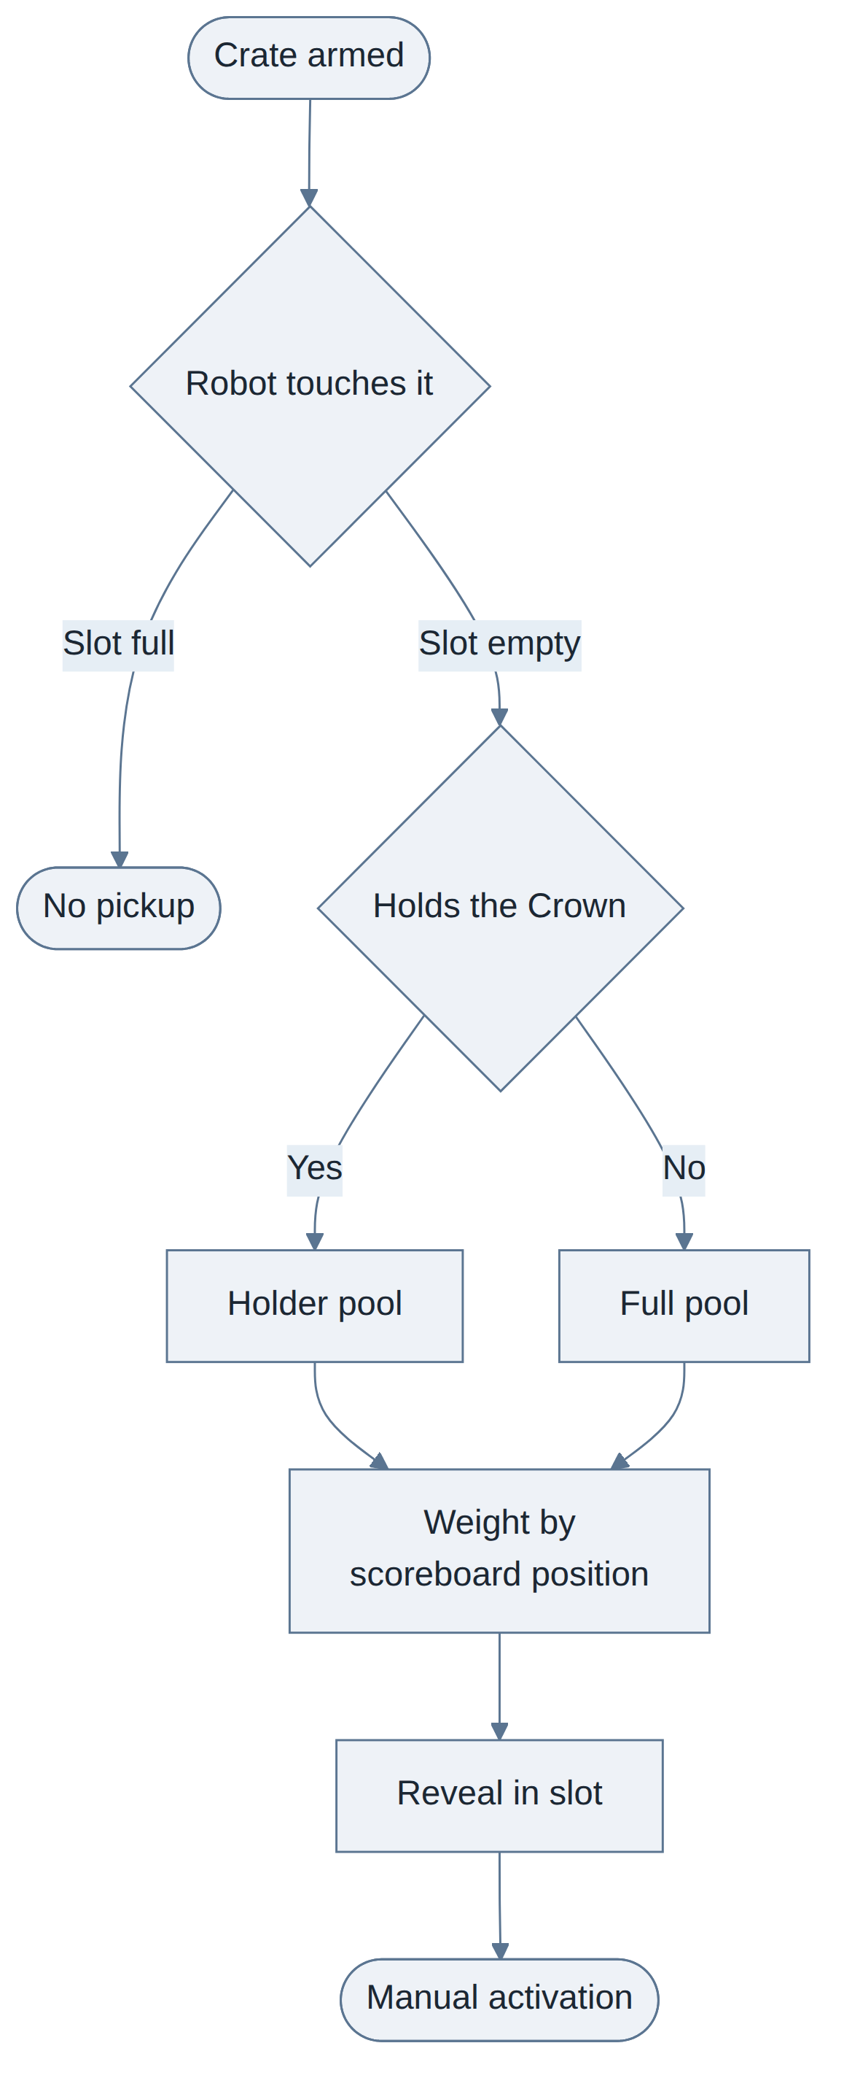
Rule | Value | Why
Carry limit | Exactly one, no stockpiling | Stockpiling creates a save-it-for-the-end meta and turns the last stretch into a burst of simultaneous effects nobody can parse
Activation | Manual, on a dedicated input | Auto-activation removes the only decision the system offers
Roll bias | Trailing players roll from shifted weights | Never announced, never shown. The crate makes this free — the player had no expectation of what they would get
Repulse Pulse weight | Low for everyone, and not raised by the trailing bias | It is the most disruptive item in the set. Rare keeps it a moment rather than a nuisance
Holder pool | The holder cannot roll Grapple Field | It would do nothing. Stated so a roll never produces a dead pickup
Crate arm delay | crate_arm_delay after spawn | Stops a free instant pickup
Simultaneous pickup | First touch on the authority tick wins; the loser gets nothing and the crate enters its respawn timer | Consistent with the foundation's contact tie-breaking
Determinism | Rolls are authority-side and replicated. No unseeded randomness — a deterministic function of tick and ParticipantRef, per the foundation and FD-07 | Required, not optional

The sixth input
Manual activation needs a control the foundation does not have. Input & Camera v0.3 states there are five inputs and that "a sixth input is a foundation-level change, not a per-game one."
Design's position: add it. The foundation exists to make future games faster to build, not to fix the input vocabulary permanently, and a power-up button is a normal thing for a mini-game to want. Concretely this means one more bit in NetworkInput's button bitfield and one binding per control scheme.
Scheme | Provisional binding
Keyboard | Left Ctrl or E
Gamepad | Left shoulder

Needs the foundation team's sign-off, since it touches the replicated input struct.

UI
Element | Anchor | Behaviour
Power-up slot | Bottom centre | Icon and key prompt. The empty slot stays visible, so players learn the slot exists before they ever fill one. Bottom centre because it sits in the driving sightline
Reveal | Slot | Roll-and-settle on pickup, ~0.5 s. This is the moment that makes a crate feel like a prize
Active effect | Slot | Radial timer counting the effect down. Visually distinct from a held, unused item
Crate world marker | World | Visible at range. Clearly inert during crate_arm_delay
Damper Field ring | World, on the robot | Replicated to all clients. Non-negotiable, per the Damper Field row above
Repulse charge-up | World, on the robot | Visible to everyone before the pulse fires. The telegraph is what makes it fair
Event feed | Bottom left | Two to three auto-fading lines: steals, pickups, activations. Cheap, and worth a lot at 5-6 players where much happens off-camera

No inventory UI. There is one slot by design.

Audio
Cue | Trigger
Crate break | Pickup
Reveal | Roll settles on the item
Activation | Per item, distinct
Expiry | Effect ends — a player must know when Damper Field drops without watching the HUD

Tuning
Parameter | Provisional | Range
crate_count | 5 | 3 to 8
crate_respawn | 12 s | 8 to 20
crate_arm_delay | 1 s | 0.5 to 2
overdrive_ticks | Stage 2 boost_ticks equivalent | —
overdrive_strength | Stage 2 boost_multiplier | Stage 1 to 3
grapple_ticks | 6 s | 4 to 8
grapple_reach_bonus | Small — a near-miss, not an aura | —
damper_ticks | 5 s | 3 to 7
oil_patch_lifetime | 8 s | 5 to 15
repulse_weight | Low, exact value unset | —

damper_ticks feels longest to the opponents, not to the user. Keep it short.

Edge cases
Case | Handling
Pickup while the slot is full | No pickup, crate stays active. No auto-swap — losing a saved item to an accidental drive-over is exactly the unearned loss this mode avoids
Crate spawns under a moving robot | crate_arm_delay covers it
Overdrive fired while a drift boost is active | One chain link taking the higher multiplier, per the foundation. Never additive
Oil dropped under the dropper | They drive onto their own oil. Legitimate and funny — no exclusion rule
Two oil patches overlap | Surfaces do not stack; the probe majority rule resolves a single tag, per the Drive Model
Repulse fired with nobody nearby | Fires, does nothing, is consumed. No refund — committing the item is the decision
Repulse shoves the Crown holder | Physics only. A shove has no aggressor doing the closing, so it never transfers the Crown
An effect is active when the round ends | Nothing special. Modifier sets are cleared on scene teardown, per Handling Profiles
A player is spun out holding an item | Keeps it. The slot is unaffected by recovery states
A bot picks up a crate | Same pools and same weights as a player. Bots fire whatever they roll, immediately — see FD-07

